[https://remix.ethereum.org/#optimize=false&evmVersion=null&version=soljson-v0.5.17+commit.d19bba13.js](https://remix.ethereum.org/" \l "optimize=false&evmVersion=null&version=soljson-v0.5.17+commit.d19bba13.js)

AssociateProfitSplitter

0xF8ef6A11d76dB9e0AaE21146592565E239F9445f

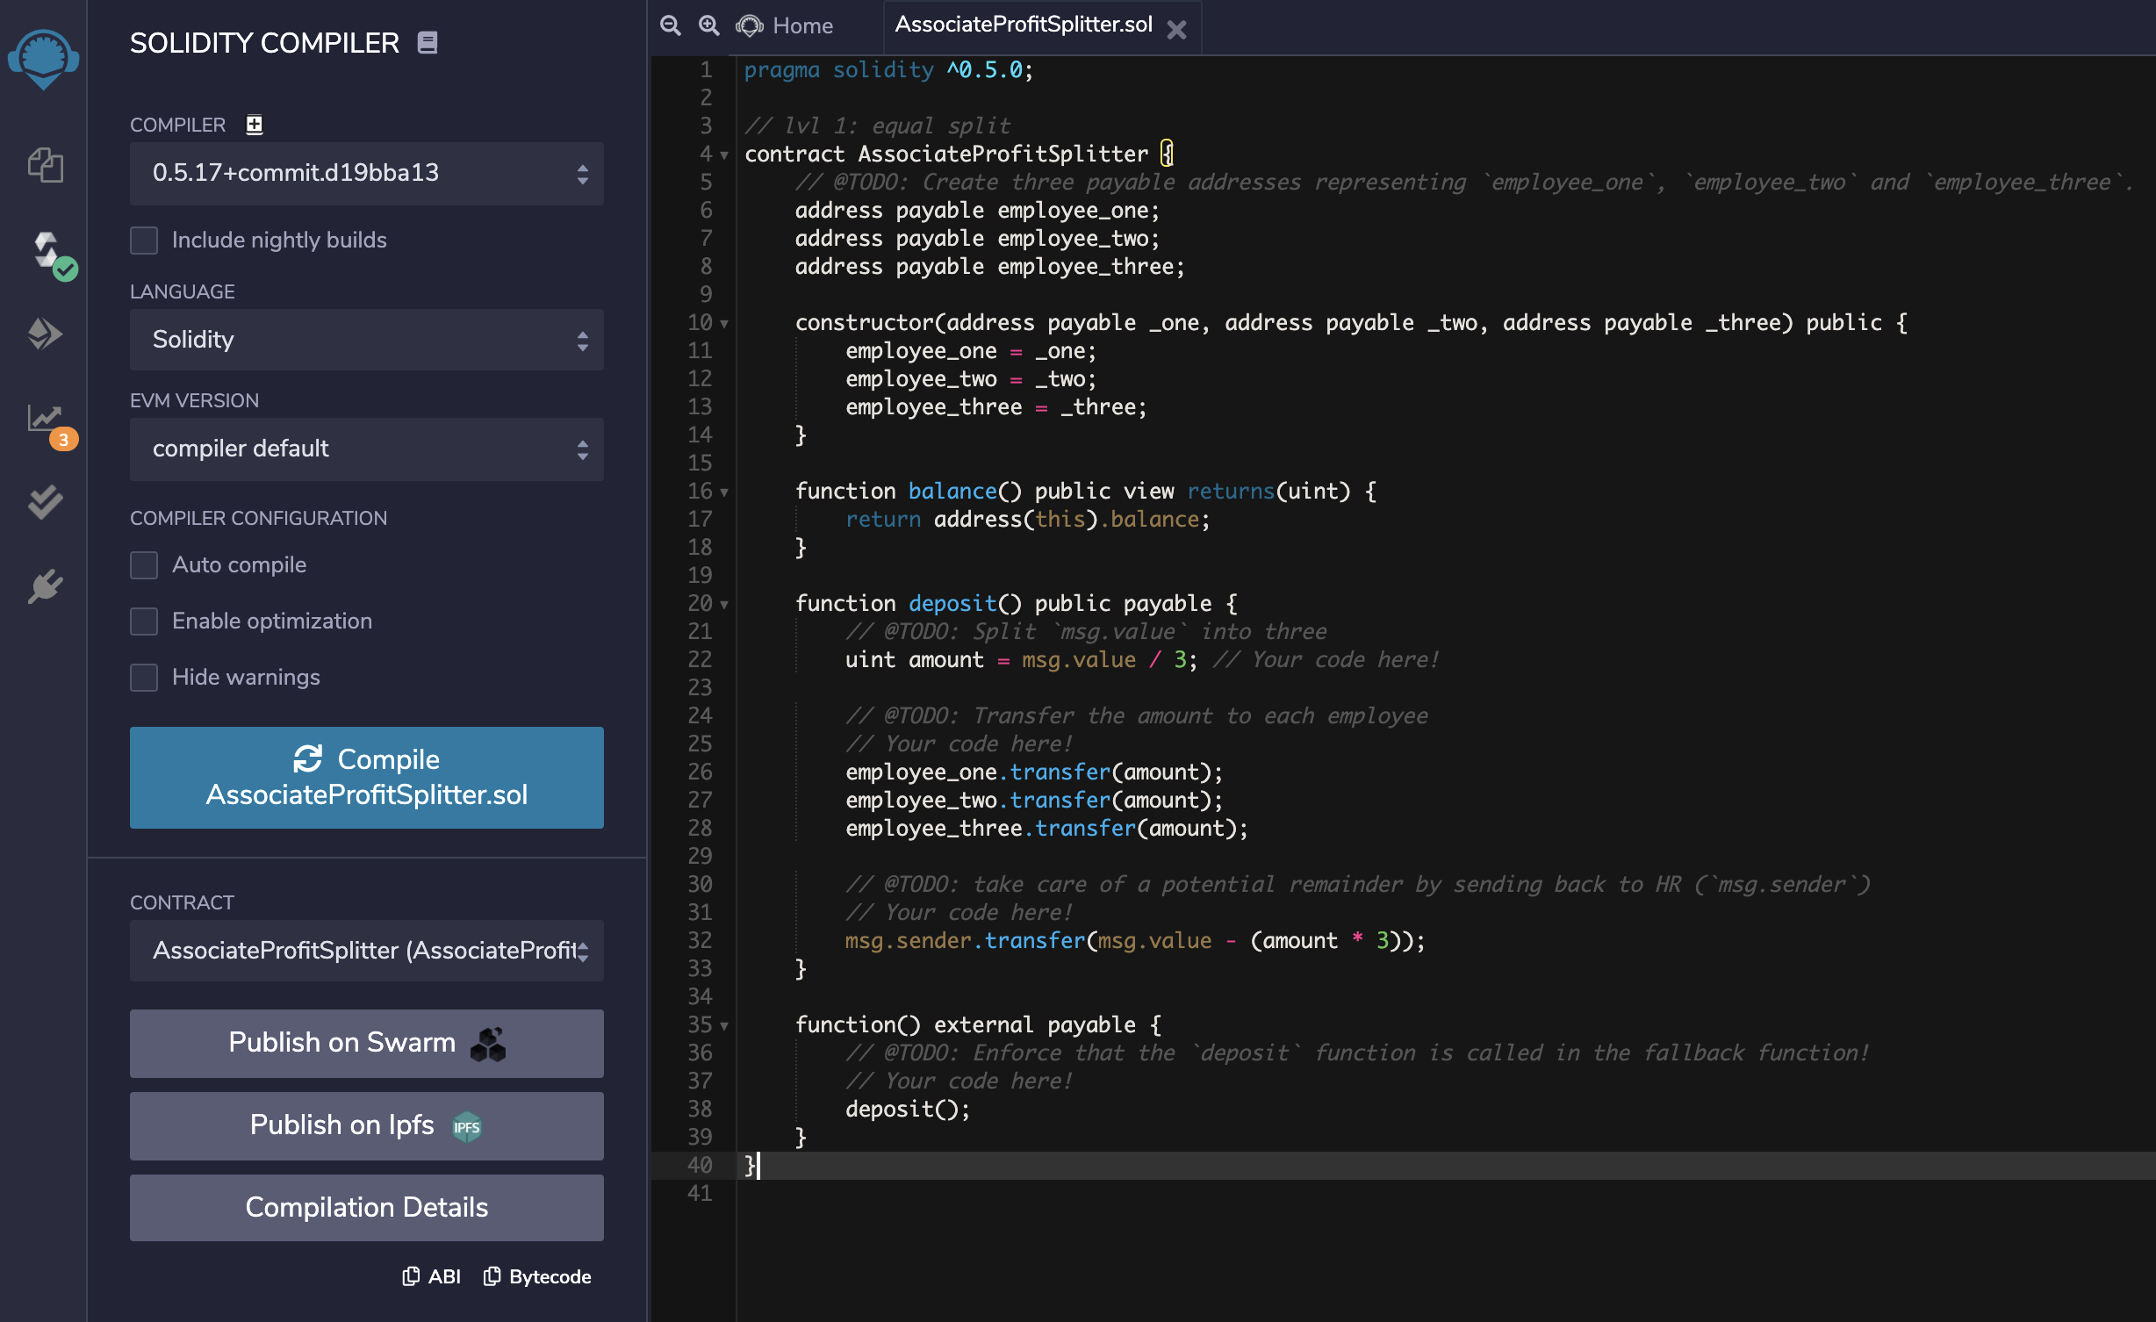

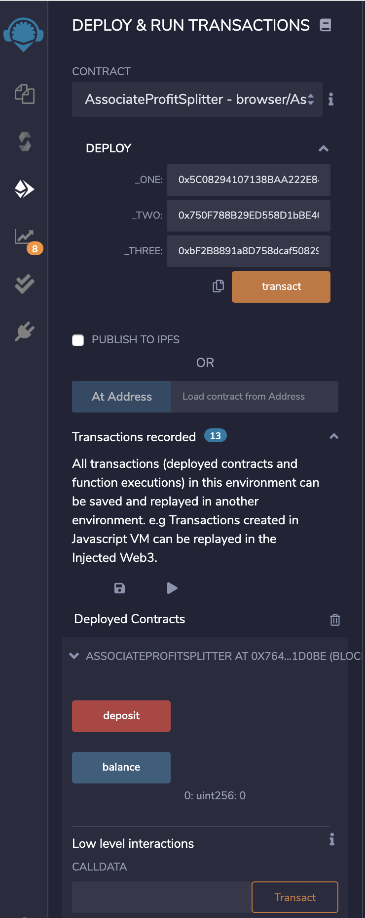

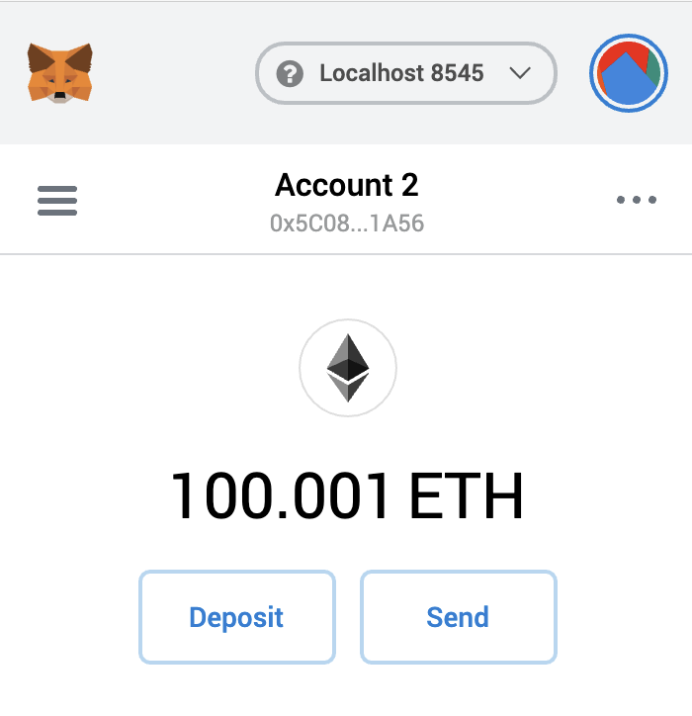

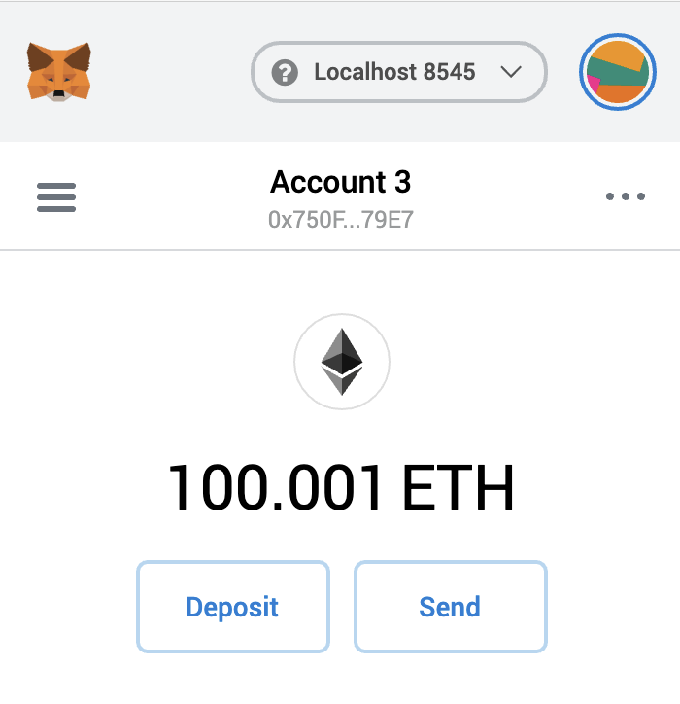

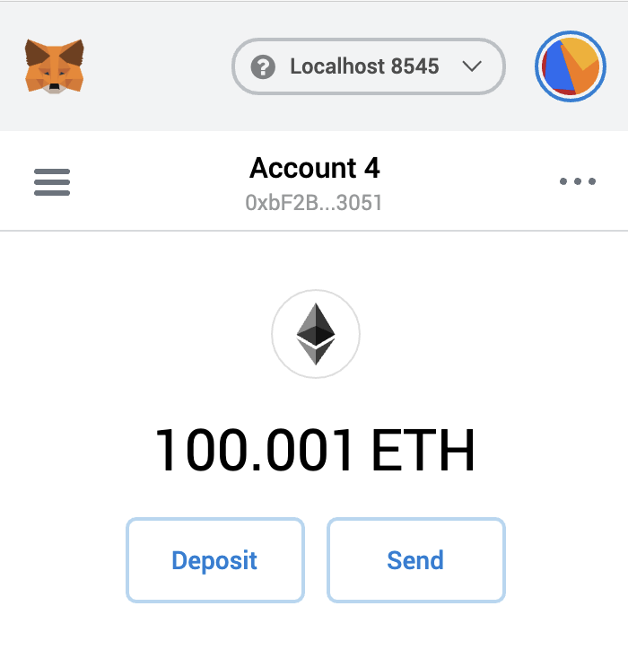

**TieredProfitSplitter**

**0x7768f0270C5f645020640f90c901EBD7E07f455a**

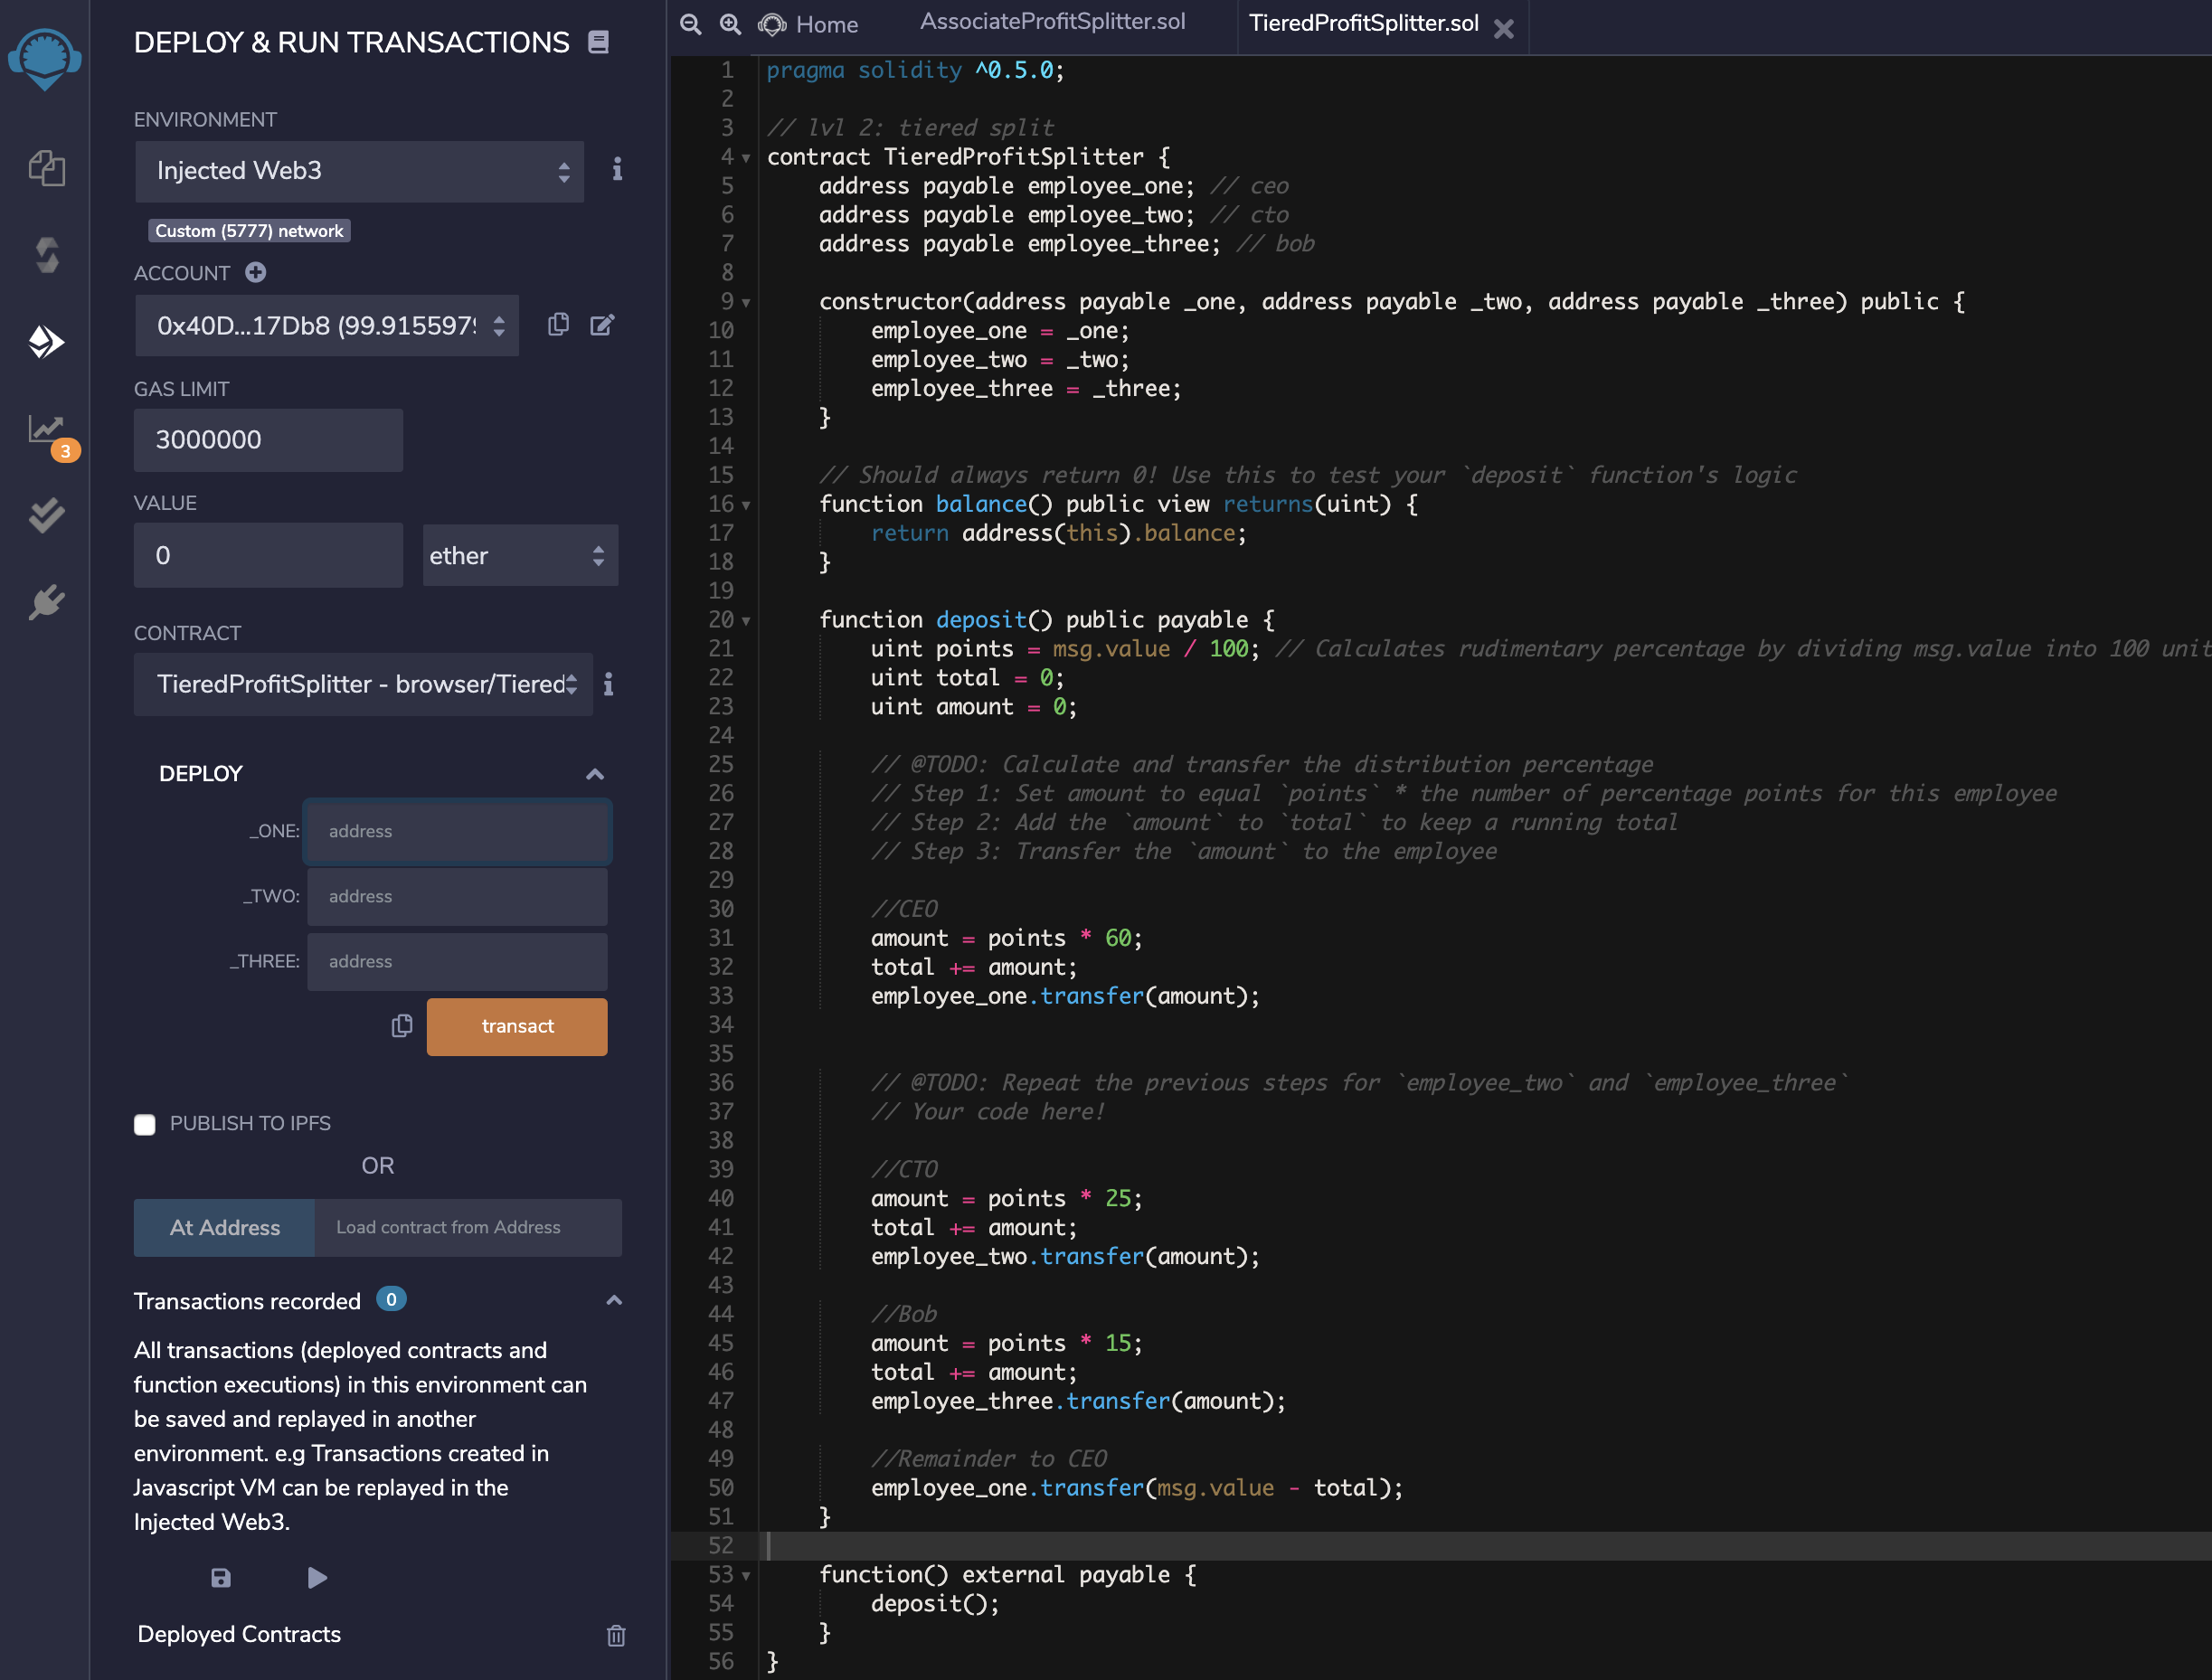

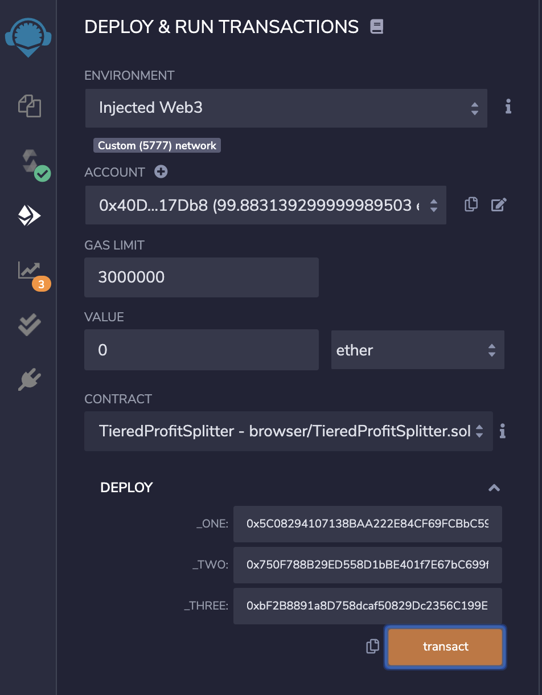

HR Address: **0x40De7759EF972F8DB32D0cf55b589d37ec817Db8**

CEO Address: **0x5C08294107138BAA222E84CF69FCBbC599081A56**

CTO Address: **0x750F788B29ED558D1bBE401f7E67bC699fbe79E7**

Bob Address: **0xbF2B8891a8D758dcaf50829Dc2356C199E0f3051**

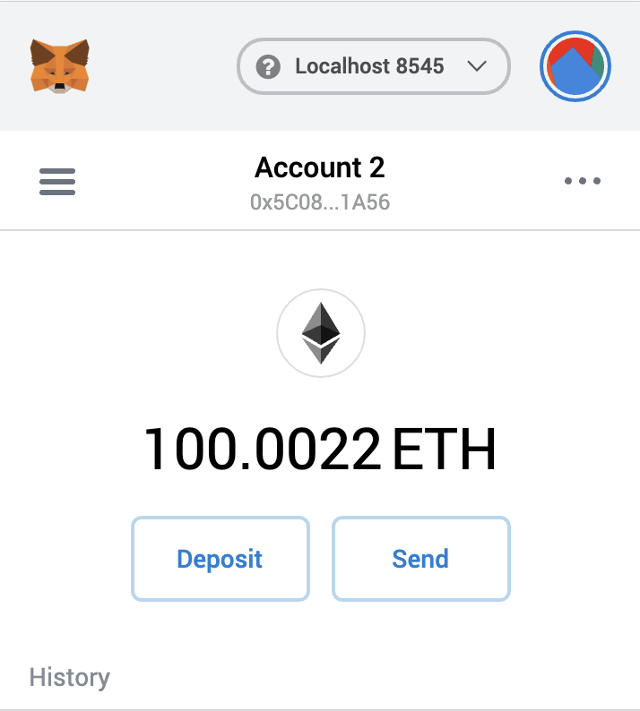

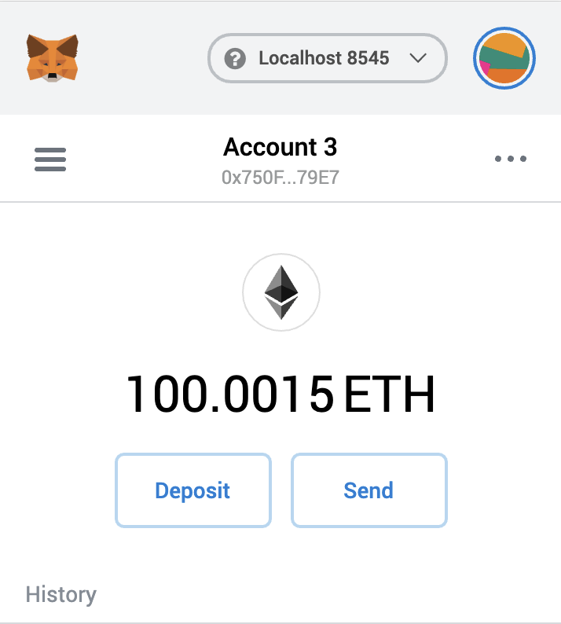

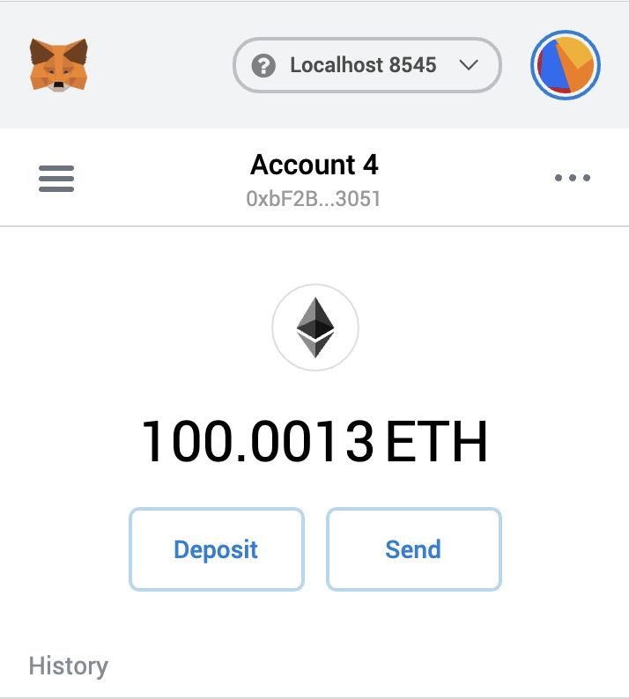

### DeferredEquityPlan

### 0x7d56EFc60d02db2B1CdbC2519cC63c370f2E34C9

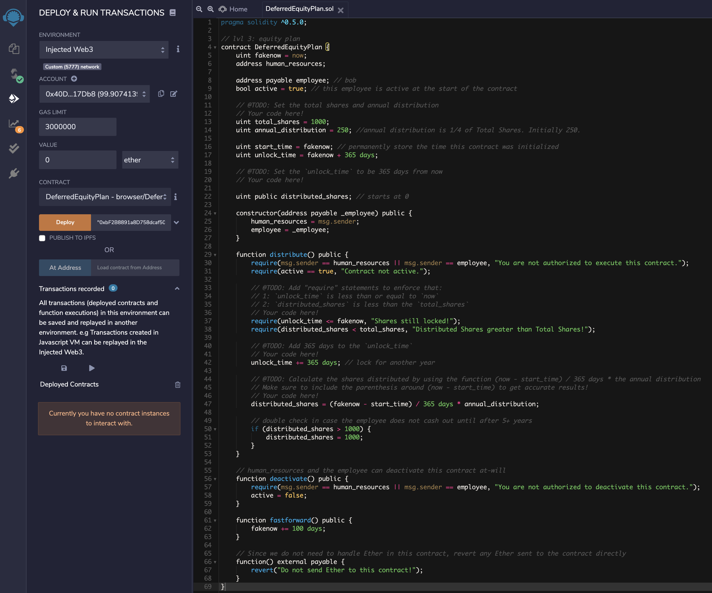

HR Address: **0x40De7759EF972F8DB32D0cf55b589d37ec817Db8**

CEO Address: **0x5C08294107138BAA222E84CF69FCBbC599081A56**

CTO Address: **0x750F788B29ED558D1bBE401f7E67bC699fbe79E7**

Bob Address: **0xbF2B8891a8D758dcaf50829Dc2356C199E0f3051**

